Equipment Used:

* Myo armband EMG Sensor (By Thalmic Lab)

**Introduction:**

The Myo armband by Thalmic Labs is an innovative wearable device that utilizes electromyography (EMG) to detect and interpret the electrical activity produced by muscles in the arm. This allows users to control various digital devices and applications through gestures and motions.

**Specifications:**

1. **EMG Sensors**
   * 1. 8 channels
     2. 200 Hz to 1000 Hz S.Rate
     3. 8-10 bits Resolution
2. **IMU Sensors**
   * 1. Accelerometer, Gyroscope, Magnetometer
     2. 50 Hz to 200 Hz S.Rate
     3. 16 bits for accelerometer and gyroscope, and 12 bits for magnetometer Resolution
3. **Connectivity:**
   * 1. Bluetooth Low Energy (BLE) 4.0 or later
     2. 10 meters Range
4. **Battery:**
   * 1. 100-150 mAh
     2. Charging Time: 1-2 Hours
     3. 4-8 hours continuous
5. **Gesture Recognition**

Supported gestures: Includes various hand and arm movements such as flexion, extension, rotation, and gestures like pinch, swipe, and tap

* **Raspberry Pi:**

Introduction:

The Raspberry Pi 3 Model B+ Rev 2 is a versatile single-board computer developed by the Raspberry Pi Foundation. It builds upon the success of previous Raspberry Pi models, offering enhanced performance, connectivity, and features for various computing projects and applications. The Raspberry Pi can be used to prototype AI and ML projects before scaling them to more powerful hardware. This includes tasks like image recognition, voice recognition, and sensor data analysis. While the Raspberry Pi 3 B+ Rev 2 has limited computational power compared to high-end servers or GPUs, it can still run lightweight AI and ML models efficiently.

* **Robotic Glove / Arm:**

1. **Glove Design:**

Using flexible tubes and fiber-type cloth designed on Coral Draw for the left hand. This design likely allows for comfortable wear and movement while providing the structure necessary for the robotic components. *(Coral Draw Desing Image wil be added after).*

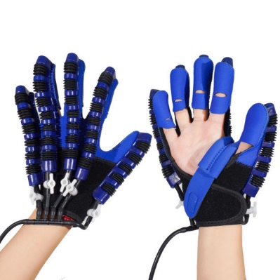

1. **12V DC Air Pump:**

This pump serves as the source of air pressure for the system. It draws in air and pressurizes it before delivering it to the solenoids. the air pressure needed to actuate the solenoids, which in turn control the movement of the fingers in your robotic hand. By adjusting the voltage supplied to the air pump, you can regulate the speed of the pump or the intensity of its operation. This, in turn, affects the air pressure generated by the pump. Increasing the voltage typically results in higher pressure, while decreasing it reduces pressure.

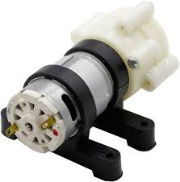

1. **Solenoids:**
   1. **24V Solenoids**

two 24V solenoids, which likely serve specific functions within the hand mechanism. Solenoids are electromechanical devices that convert electrical energy into linear motion.

*Function:*

“Solenoids can act as effective control valves in pneumatic systems, regulating the flow of air to different components such as the fingers in your robotic hand. they likely serve as the main actuators responsible for opening and closing the air passages to each finger, allowing for precise control of movement.”

* 1. **5V Solenoid Valves**

These valves act as switches for the airflow to each finger. When activated, they open or close, allowing air to flow through the corresponding air tube and into the flexible tubes connected to each finger of the glove.

*Function:*

” The primary function of the solenoid valves is to regulate the airflow to each finger of the robotic hand. By opening and closing the valves in response to commands from the control system (in this case, the Arduino Uno), the flow of compressed air to specific pneumatic actuators associated with each finger can be precisely controlled.”

1. **Relays:**

The relay in your robotic glove setup plays a vital role in managing the power supply, ensuring compatibility between different voltage levels, providing safety features, and enabling control logic implemented by the Arduino Uno.

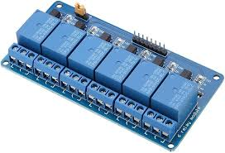

1. **Batteries:**

Connecting the batteries in series adds their individual voltages together. So, two 12V batteries in series would result in a total voltage output of 24V. This matches the voltage requirements of components like the solenoids and the relay in your robotic glove.

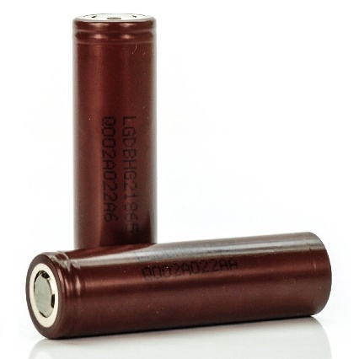

1. **Arduino Uno:**

The Arduino Uno serves as the microcontroller and brain of your system. It is programmed to interpret commands and control the various components of your robotic glove based on input signals.

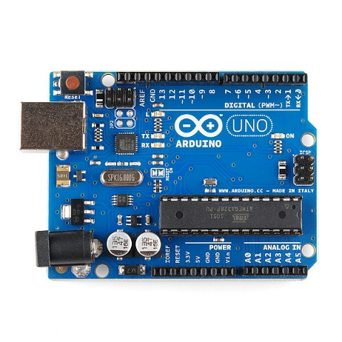

1. **Bluetooth Module:**

The Bluetooth module on the Arduino Uno is used to establish a wireless connection with the Raspberry Pi. Common Bluetooth modules used with Arduino include HC-06 module.

This communication can be established using serial communication protocols such as UART (Universal Asynchronous Receiver-Transmitter) over Bluetooth. The Raspberry Pi can send data packets containing information about the recognized gesture to the Arduino Uno over the Bluetooth connection Upon receiving the gesture data, the Arduino Uno can interpret it and trigger specific actions or movements in your robotic hand based on predefined mappings. For example, if a certain gesture corresponds to closing the robotic hand, the Arduino Uno can activate the necessary solenoids or valves to execute that movement.

